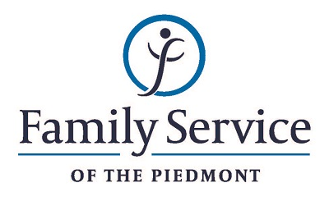

POSITION ANNOUNCEMENT
DVIP Case Manager
September 14, 2018

Family Service of the Piedmont is a not for profit agency whose mission is to promote healthy lives and relationships for children, families and individuals, through early intervention, treatment and support in times of crisis or transition.

The agency is seeking DVIP Case Manager to provide comprehensive services to men enrolled in the Domestic Violence Intervention Program and victims of domestic violence and to serve as Agency liaison with the judicial system.

Responsibilities:
- Provides initial and follow up intakes for clients who are court ordered, DSS referred, or self-referred to DVIP. Schedule DVIP orientations.
- Assists with group facilitation.
- Provide solution-focused case management to clients at specific times during the program.
- Create and maintain client files.
- Documents services by completing monthly and quarterly reports and completing other documentation as required by Agency, accreditation and ethical standards.
- Communicate with probation officers, District Attorneys, and other community agencies as needed regarding compliance with DVIP.
- Educates the community about family violence, sexual assault and other crimes by training and providing community education programs.
- Connects victims to Victim Advocates for assistance as needed or requested for advocacy services such as supportive counseling follow up, court accompaniment or obtaining a domestic violence protection order.
- Maintains harmonious working environment by participation in team and staff meetings, consulting with staff regarding topic areas, respecting cultural and lifestyle differences and by providing support and encouragement to other staff members.
- Assists agency in overall service delivery by performing other administrative duties as delegated or required.

Qualifications:
- The ability to respond appropriately to the cultural differences present among the organization’s service population and staff is required.
- Ability to work in partnership with other team members.
- Ability to forge a mutually respectful partnership with persons served and their families in which they are helped to gain the skills and confidence to address issues and problems they face.
- Conviction about the capacity of people to grow and change.
- Ability to set limits and maintain the helping role of the practitioner and to intervene appropriately to meet the needs of the persons served or other family members.
- Valid driver’s license, clean driving record and the ability to operate a motor vehicle.
- Ability to sit, stand, walk, lift light objects as needed, move about the office or otherwise perform the physical tasks required to perform the duties listed above.
- 1 year of Case Management experience required.
- 1 year of working with offender populations required; specifically domestic violence offenders preferred.
- Minimum of Bachelor’s level degree in criminal justice, human service or related field.

Send resume and letter by September 28, 2018 to:
Human Resources
Family Service of the Piedmont
902 Bonner Drive
Jamestown, NC 27282

FAMILY SERVICE OF THE PIEDMONT IS AN EQUAL OPPORTUNITY EMPLOYER

