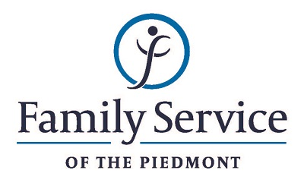

POSITION ANNOUNCEMENT
Sexual Assault Victim Advocate
September 14, 2018

Family Service of the Piedmont is a not for profit agency whose mission is to promote healthy lives and relationships for children, families and individuals, through early intervention, treatment and support in times of crisis or transition.

The agency is seeking a Sexual Assault Victim Advocate to provide comprehensive services to victims of sexual assault and their families.

Responsibilities:
- Reduces stress and trauma for victims by providing crisis intervention and advocacy services, coordinating cases with law enforcement and the court system, referring clients to community resources, providing crisis lines services, providing support group services and accompanying clients to medical, legal or judicial procedures.
- Documents services by writing progress reports and completing other documentation as required by agency, accreditation and ethical standards.
- Provides outreach to the community regarding sexual assault services to ensure access to services.
- Identifies and provides outreach to underserved populations regarding sexual assault services to ensure access to services.
- Educates the community about sexual assault and other crimes by training and providing community education programs as needed.
- Maintains harmonious working environment by participation in team and staff meetings, consulting with staff regarding topic areas, respecting cultural and lifestyle differences and by providing support and encouragement to other staff members.
- Must be available for rotating on call for sexual assaults and after-hours events.
- Assists agency in overall service delivery by performing other administrative duties as delegated or required.

Qualifications:
- The ability to respond appropriately to the cultural differences present among the organization’s service population and staff is required.
- Ability to work in partnership with other team members.
- Ability to forge a mutually respectful partnership with persons served and their families in which they are helped to gain the skills and confidence to address any issues and problems they face.
- Conviction about the capacity of people to grow and change.
- Ability to set limits and maintain the helping role of the practitioner and to intervene appropriately to meet the needs of the persons served or other family members.
- Valid driver’s license, clean driving record and the ability to operate a motor vehicle.
- Ability to sit, stand, walk, lift light objects as needed, move about the office or otherwise perform the physical tasks required to perform the duties listed above.
- Minimum of Bachelors in human services or related field.

Send resume and letter to:
Human Resources
Family Service of the Piedmont
902 Bonner Drive
Jamestown, NC 27282

FAMILY SERVICE OF THE PIEDMONT IS AN EQUAL OPPORTUNITY EMPLOYER

