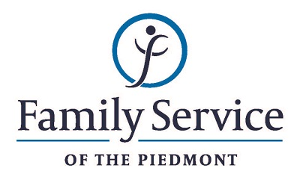

POSITION ANNOUNCEMENT

Marketing and Communications Coordinator
October 10, 2018

Family Service of the Piedmont is a not for profit agency whose mission is to promote healthy lives and relationships for children, families and individuals, through early intervention, treatment and support in times of crisis or transition.

The agency is seeking a Marketing and Communications Coordinator to coordinate the functions of marketing and communication activities for the Agency.

Responsibilities:
- Assist in the development and implementation of the Marketing and Communications Strategy for the agency.
- Develop media relations and be the point person for media calls.
- Work to enhance the FSP brand and define the message of the agency.
- Seek out and develop new and innovative marketing opportunities for the agency.
- Manage Staff Annual Campaign to increase participation and education of the staff.
- Develop and manage agency marketing materials, including Impact Report, newsletters, e-newsletters, press releases and billboards.
- Manage all social media of the agency including all Facebook pages, Twitter, YouTube and LinkedIn as needed.
- Track usage and impact of social media of the agency.
- Perform all photography and videography needed for the agency.
- Represent marketing and development team in planning and execution of all awareness events.
- Create and maintain marketing and communications calendar.
- Assist CEO Team with internal communications.
- Update all marketing materials.

Qualifications:
- The ability to respond appropriately to the cultural differences present among the organization’s service population and staff is required.
- The ability to respond in a timely and effective manner to the needs of staff, volunteers and other constituents.
- Ability to work in partnership with other team members.
- Experience with MS Office Suite.
- Organizational, project planning and leadership skills.
- Excellent verbal, written and interpersonal skills.
- Degree in Mass Communications, Marketing, Business or other related degree.

Send resume and letter to:
Human Resources
Family Service of the Piedmont
902 Bonner Drive
Jamestown, NC 27282

FAMILY SERVICE OF THE PIEDMONT IS AN EQUAL OPPORTUNITY EMPLOYER

