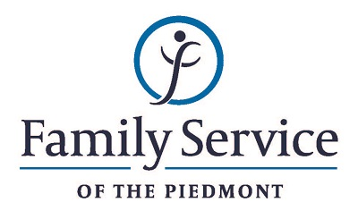

POSITION ANNOUNCEMENT

Director of Victim Services
September 24, 2018

Family Service of the Piedmont is a not for profit agency whose mission is to promote healthy lives and relationships for children, families and individuals, through early intervention, treatment and support in times of crisis or transition.

The agency is seeking a Director of Victim Services to provide leadership to the Victim Services Division to ensure quality services, fiscal accountability and programmatic structure.

Responsibilities:
- Utilize the Strategic Plan to guide programs in the Victim Services Division.
- Lead division staff by setting expectations, coaching, training, implementing best practices and ensuring a healthy, productive working environment.
- Provide administrative and programmatic oversight to the programs in the Victim Services Division, which includes recommendations on all decisions about hiring, transferring, promoting, and disciplinary action of division staff; reviewing and approving staff evaluations; ensuring staff opportunities for educational and professional growth; and complying with funder requirements.
- Have a working knowledge of program funding sources and all associated statutes and required outcomes.
- Provide direct supervision to Victim Services Program Coordinators
- Maintain a client centered approach by providing case consultation, maintaining uniform policies and procedures, following ethical standards and coordinating services with other programs within the agency.
- Ensure quality services by maintaining standards set by the Agency’s accrediting agents, and other standards of accountability including record documentation, outcome measurements and Quality Assurance/Quality Improvement functions.
- Promote the Victim Services Division and the agency in the community by cultivating and maintaining relationships with other agencies, organizations, colleges and universities for cooperation and collaboration on services and referrals; and by other marketing strategies.
- Work to secure grants or other funding to help assure fiscal viability of division programs
- Assume budgetary responsibility for the division.
- Serve on the Agency Leadership Team and perform other duties and responsibilities as requested by the Chief Program Officer and as needed for effective Agency functioning.

Qualifications:
- The ability to respond appropriately to the cultural differences present among the organization’s service population and staff is required.
- Ability to work in partnership with other team members.
- Ability to forge a mutual respectful partnership with persons served and their families in which they are helped to gain the skills and confidence to address any issues and problems they face.
- Conviction about the capacity of people to grow and change.
- Ability to set limits and maintain the helping role of the practitioner and to intervene appropriately to meet the needs of the persons served or other family members.
- Able to climb stairs, bend, reach high and be on feet for up to 8 hours at a time and able to lift at least 30 pounds.
- Minimum of three years supervisory experience required.
- Bachelor’s degree in human services or related field required; Master’s Degree or equivalent experience preferred.

Send resume and letter to:
Human Resources
Family Service of the Piedmont
902 Bonner Drive
Jamestown, NC 27282

FAMILY SERVICE OF THE PIEDMONT IS AN EQUAL OPPORTUNITY EMPLOYER

