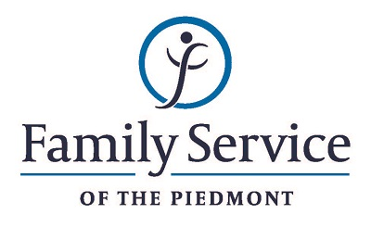

POSITION ANNOUNCEMENT
Dual Diagnosis Case Manager
September 6, 2018

Family Service of the Piedmont is a not for profit agency whose mission is to promote healthy lives and relationships for children, families and individuals, through early intervention, treatment and support in times of crisis or transition.

The agency is seeking a Dual Diagnosis Case Manager & Intake Specialist to coordinate treatment services, enhance client engagement and provide support to dually diagnosed clients and their families. Provide agency intake services and other administrative services as needed.

Responsibilities:
- Perform intake duties to ensure a welcoming point of entry for all telephone and walk-in inquiries for services, including: working collaboratively with other agency departments to ensure a smooth entry into services for patients. Coordinate with Family Service staff to schedule assessments and other treatment related appointments
- Provide quality, culturally sensitive, respectful case management services to a diverse client population.
- Maintain harmonious relationships with the multidisciplinary team and community organizations.
- Coordinate care with other community based service providers or other legally interested parties as needed.
- Meet with clients and behavioral health providers, and other staff as needed, to develop and coordinate treatment plans.
- Maintain ongoing client contact to promote client engagement and keep team aware of any client issues affecting treatment, including conducting appointment reminder calls for the Dual Diagnosis program.
- Maintain appropriate documentation on referrals and referral sources. Ensure that referrals are addressed in a timely manner. Assist clients in problem solving systemic, financial or social issues.
- Coordinate contingency management program.
- Point of contact for clients and families. Advocate on client’s behalf as needed.
- Assist in recording and tabulating outcome data; assist in required reporting.
- Participates on the Counseling Services team and performs other activities, duties or assignments as may be needed for effective agency functioning.

Qualifications:
- Ability to forge a mutually respectful partnership with persons served and their families in which they are helped to gain the skills and confidence to address any issues and problems they face.
- The ability to respond appropriately to the cultural differences present among the organization’s service population and staff is required.
- Ability to work in partnership with other team members.
- Conviction about the capacity of people to grow and change.
- Ability to set limits and maintain the helping role of the practitioner and to intervene appropriately to meet the needs of the persons served or other family members.
- Computer literacy.
- Strong customer service and organizational skills
- Resourcefulness in problem solving.
- Experience working with substance abuse and mental health required.
- Bachelor’s degree in psychology, social work or related field required.

Send resume and letter to:
Human Resources
Family Service of the Piedmont
902 Bonner Drive
Jamestown, NC 27282

FAMILY SERVICE OF THE PIEDMONT IS AN EQUAL OPPORTUNITY EMPLOYER

