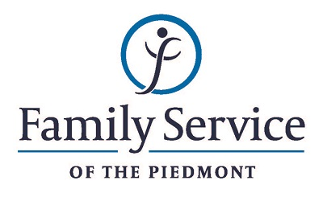

POSITION ANNOUNCEMENT
DVIP Program Coordinator
October 18, 2018

Family Service of the Piedmont is a not for profit agency whose mission is to promote healthy lives and relationships for children, families and individuals, through early intervention, treatment and support in times of crisis or transition.

The agency is seeking DVIP Program Coordinator to manage the overall functioning of the Domestic Violence Intervention Program, to provide outreach to the community, to provide supervision to DVIP staff and to ensure overall program fidelity and excellence.

Responsibilities:
- Delivers treatment services to clients by using individual, family and group treatment modalities.
- Assures a quality group treatment program by recruiting, training and supervising group leaders and other DVIP staff, monitoring uniform group practice and procedures and complying with all ethical and accreditation standards.
- Documents services by formulating assessment and treatment plans, writing progress reports and completing other documentation as required by agency, accreditation and ethical standards.
- Educates the community about family violence, sexual assault and other crimes by training and providing community education programs as needed.
- Maintains harmonious working environment by participation in team and staff meetings, consulting with staff regarding topic areas, respecting cultural and lifestyle differences and by providing support and encouragement to other staff members.
- Assists agency in overall service delivery by performing other administrative duties as delegated or required.

Qualifications:
- The ability to respond appropriately to the cultural differences present among the organization’s service population and staff is required.
- Ability to work in partnership with other team members.
- Ability to forge a mutually respectful partnership with persons served and their families in which they are helped to gain the skills and confidence to address any issues and problems they face.
- Conviction about the capacity of people to grow and change.
- Ability to set limits and maintain the helping role of the practitioner and to intervene appropriately to meet the needs of the persons served or other family members.
- Minimum of Bachelor’s level degree in criminal justice, human service or related field.

Send resume and letter to:
Human Resources
Family Service of the Piedmont
902 Bonner Drive
Jamestown, NC 27282

FAMILY SERVICE OF THE PIEDMONT IS AN EQUAL OPPORTUNITY EMPLOYER

