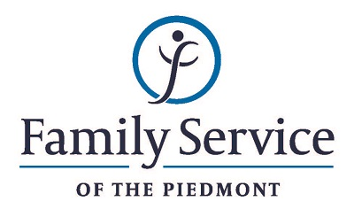

POSITION ANNOUNCEMENT
Hospital Liaison Case Manager
November 13, 2018

Family Service of the Piedmont is a not for profit agency whose mission is to promote healthy lives and relationships for children, families and individuals, through early intervention, treatment and support in times of crisis or transition.

The agency is seeking a Hospital Liaison Case Manager to work to ensure behavioral health patients being discharged from a psychiatric hospital admission are referred to an appropriate level of care and receive attentive support services during the transitional period.

Responsibilities:
- Provide supportive services to clients preparing to discharge from a psychiatric admission by visiting clients in the hospital prior to discharge and offering supportive, short term case management services, including assessment of appropriate level of care needed, referrals to appropriate services and follow up to encourage client engagement in recommended services.
- Work with hospital staff as part of the discharge process to determine appropriate level of care needed upon discharge.
- Assist client in arranging referral to appropriate agency; if needed; meet client at treating agency for first appointment; follow up with client and agency staff to ensure client engages in treatment services.
- Develop collaborative network of referral sources both internal and external to the agency.
- Maintain a client centered approach and follow the highest ethical standards.
- Understand uniform policies and procedures of the program and the Agency.
- Maintain standards set by the Agency’s accrediting agents, and other standards of accountability including clinical record documentation, outcome measurements and Quality Assurance/Quality Improvement functions.
- Perform other duties and responsibilities as requested by the supervisor and as needed for effective Agency functioning.

Qualifications:
- The ability to respond appropriately to the cultural differences present among the organization’s service population and staff is required.
- Ability to work in partnership with other team members.
- Ability to forge a mutual respectful partnership with persons served and their families in which they are helped to gain the skills and confidence to address any issues and problems they face.
- Conviction about the capacity of people to grow and change.
- Valid NC driver’s license and reliable transportation
- Ability to remain standing for extended periods; ability to navigate stairs and within institutional settings and offices.
- Master’s Degree in social work or related field; LCSWA, LPCA or LCASA preferred
- Minimum of three years’ experience in human services organization.

Send resume and letter by November 27, 2018 to:

Human Resources
Family Service of the Piedmont
902 Bonner Drive
Jamestown, NC 27282

FAMILY SERVICE OF THE PIEDMONT IS AN EQUAL OPPORTUNITY EMPLOYER

