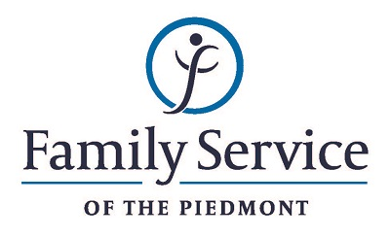

POSITION ANNOUNCEMENT
Outpatient Mental Health Therapist – Child Trauma Focused
December 4, 2018

Family Service of the Piedmont is a not for profit agency whose mission is to promote healthy lives and relationships for children, families and individuals, through early intervention, treatment and support in times of crisis or transition.

The agency is seeking a Child/Trauma Focused Outpatient Mental Health Therapist to provide individual, group and family therapy to children and families who have been impacted by trauma.

Responsibilities:
- Provides quality, culturally sensitive, respectful treatment services to a diverse population by using individual, family and group modalities.
- Documents all treatment services by formulating assessment and treatment plans, writing progress reports and transfer/termination summaries and completing other documentation as required by agency and ethical standards. Documentation is to be submitted in a timely manner.
- Maintains harmonious relationships with community organizations by providing professional liaison concerning specific cases when indicated, and by providing consultation and advocacy when appropriate.
- Maintains positive relationships with all team members and staff by contributing to team cohesiveness, by consulting and collaborating with other staff as needed, and by fostering an atmosphere of tolerance of cultural and lifestyle differences.
- Plan, coordinate, and facilitate children groups as designated by the Director of Counseling Services.
- Present as the Mental Health representative at team case review meetings.
- Maintains licensure through continuing education experiences as required.

Qualifications:
- The ability to respond appropriately to the cultural differences present among the organization’s service population and staff is required.
- Ability to work well with others diplomatically in an effort to establish a positive relationship with partners both internally and externally.
- Ability to forge a mutually respectful partnership with persons served and their families in which they are helped to gain the skills and confidence to address any issues and problems they face.
- Conviction about the capacity of people to grow and change.
- Ability to set limits and maintain the helping role of the practitioner and to intervene appropriately to meet the needs of the persons served or other family members.
- 2-5 years of experience working in the treatment and advocacy of children and families exposed to trauma.
- Experience working with traumatized children.
- Trauma Focused Cognitive Behavioral Therapy certification required.
- Master’s degree in social work, counseling, or related field; NC licensure required. LCSW strongly preferred.

Send resume and letter by December 18, 2018 to:

Human Resources
Family Service of the Piedmont
902 Bonner Drive
Jamestown, NC 27282

FAMILY SERVICE OF THE PIEDMONT IS AN EQUAL OPPORTUNITY EMPLOYER

