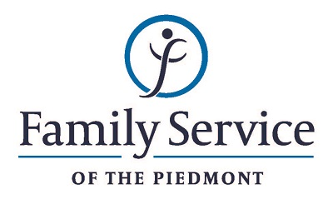

POSITION ANNOUNCEMENT

Accounts Receivable Assistant – Part-time
July 16, 2018

Family Service of the Piedmont is a not for profit agency whose mission is to promote healthy lives and relationships for children, families and individuals, through early intervention, treatment and support in times of crisis or transition.

The agency is seeking a Part-time Accounts Receivable Assistant to support the financial operations of the agency and to ensure timely and accurate processing of billing invoices and incoming cash items.

Responsibilities:
- Full Cycle Accounts Receivable.
- Maintaining Receivables in the Clinical software and the Accounting software.
- Maintain clean Aging Reports.
- Applications and processing on numerous payments.
- Assist Chief Financial Officer in various projects as needed.

Qualifications:
- The ability to respond appropriately to the cultural differences present among the organization’s service population and staff is required.
- Ability to work in partnership with other team members.
- Highly Efficient in Excel, Great Plains and clinical billing software experience required.
- Understanding of General Accounting processes and procedures and GAAP Principles.
- 1 – 3 years’ experience in Accounts Receivable billing, collection
- Understanding Generally Accepted Accounting Principles.
- Ability to work independently with minimal supervision.
- Must be dependable.
- Prefer an Associate degree in accounting or finance.

Send resume and letter by July 30, 2018 to:
Human Resources
Family Service of the Piedmont
902 Bonner Drive
Jamestown, NC 27282

FAMILY SERVICE OF THE PIEDMONT IS AN EQUAL OPPORTUNITY EMPLOYER

