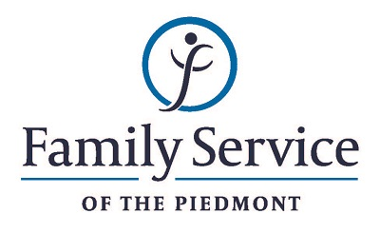

POSITION ANNOUNCEMENT
Harmony House Supervised Visitation & Exchange
Program Assistant
August 13, 2018

Family Service of the Piedmont is a not for profit agency whose mission is to promote healthy lives and relationships for children, families and individuals, through early intervention, treatment and support in times of crisis or transition.

The agency is seeking a Supervised Visitation and Exchange Program Assistant to assist the Program Coordinator in the coordination and facilitation of a safe and secure visitation and exchange center for families involved in a custodial dispute, stalking case or domestic violence situation.

Responsibilities:
- Assists the Program Coordinator with the supervised visitation program for families involved in custodial disputes, domestic violence situations and/or stalking cases.
- Assists in the development of a competent and productive staff by delegating tasks and duties, training volunteers and maintaining a harmonious and positive work environment.
- Orients parents to program guidelines and collects relevant information necessary to operate a safe and secure visitation and exchange center.
- Assists with the overall functioning of Harmony House by performing other duties as delegated or required.
- Night and weekend work required.
Qualifications:
- The ability to respond appropriately to the cultural differences present among the organization’s service population and staff is required.
- Ability to work in partnership with other team members.
- Ability to forge a mutually respectful partnership non-custodial parents, the courts and attorneys.
- Conviction about the capacity of people to grow and change.
- CPR certified or eligible for certification
- Minimum of Bachelor’s level degree in the social service field.
- Bi-lingual in Spanish strongly preferred.

Send resume and letter to:
Human Resources
Family Service of the Piedmont
902 Bonner Drive
Jamestown, NC 27282

FAMILY SERVICE OF THE PIEDMONT IS AN EQUAL OPPORTUNITY EMPLOYER

