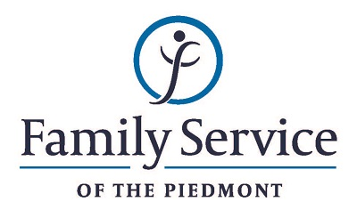

POSITION ANNOUNCEMENT
Shelter /Rapid Re-Housing Case Manager
August 23, 2018

Family Service of the Piedmont is a not for profit agency whose mission is to promote healthy lives and relationships for children, families and individuals, through early intervention, treatment and support in times of crisis or transition.

The agency is seeking a Shelter/Rapid Re-Housing Case Manager to provide comprehensive services to residents of the Victims’ shelter and assists in serving other victims of violent and /or intrusive crime.

Responsibilities:
- Delivers case management services to all victims who seek services
- Provides Rapid Re-Housing case management services to victims who enter the Rapid Re-Housing program.
- Provide clients with the tools needed to create a sustainable and safe exit plan to permanent housing, including appropriate referrals and short and long term goal planning.
- Utilize empowerment strategies to offer clients resources and service options to choose from and to provide mediation for issues resulting from the violent situation they have experienced
- Assist with the development and implementation of each individualized service plan; providing emotional support and appropriate referrals; assess eligibility for mainstream benefits/income; assist with budget planning; provide paperwork assistance as appropriate; and assist clients with receiving Victim Compensation.
- Documents treatment services by formulating assessment and treatment plans, writing progress reports and completing other documentation as required by agency and ethical standards.
- Provides advocacy services to clients by coordinating cases with local law enforcement, referring clients to community resources, assisting with crisis line coverage and accompanying clients to medical, legal or judicial procedures.
- Educates the community about family violence, sexual assault and other crimes by training and providing community education programs as needed.
- Maintains harmonious working environment by participation in team and staff meeting, consulting with staff regarding topic areas, respecting cultural and lifestyle differences and by providing support and encouragement to other staff members.
- Assist agency in overall service delivery by performing other administrative duties as delegated or required.

Qualifications:
- The ability to respond appropriately to the cultural differences present among the organization’s service population and staff is required.
- Ability to work in partnership with other team members.
- Ability to forge a mutually respectful partnership with persons served and their families in which they are helped to gain the skills and confidence to address any issues and problems they face.
- Conviction about the capacity of people to grow and change.
- Ability to set limits and maintain the helping role of the practitioner and to intervene appropriately to meet the needs of the persons served or other family members.
- Knowledge and competence of computer programs
- Must be able to lift 50lbs.
- Must be able to take initiative and self-start tasks
- Must have a valid driver’s license and reliable transportation.
- Minimum Bachelor’s degree in criminal justice, human service or related field.

Send resume and letter to:
Human Resources
Family Service of the Piedmont
902 Bonner Drive
Jamestown, NC 27282

FAMILY SERVICE OF THE PIEDMONT IS AN EQUAL OPPORTUNITY EMPLOYER

